Platform and Course Enrollment Report
Prepared Nov 2, 2026

1. Platform at a glance
Metric | Value
Total students | 1,37,431
Courses in catalogue | 63 (all Active)
Courses with at least one enrollment | 49
Courses with no enrollments yet | 14
Total course enrollments | 18,409
Hackathons (total / published) | 5 / 5
Active batches | 71
Hackathon participants | 223
The dashboard shows total students up 214788% from last month. That is reproduced as displayed; confirm the prior-month baseline it is measured against. Enrollments count a student once per course, so 18,409 enrollments is not a count of unique students.

2. Resume Analyser Monitor (last 30 days)
Metric | Value | Detail
Resumes analysed | 247 | Up 100% vs previous period
Students | 51 | Unique students, up 100%
Average resume score | 62 / 100 | Impact 42.6 · Clarity 83.2
Job-ready resumes | 21 | Latest score 70 or more
Students improving | 26 | Average change +7.7 pts
Saved to profile | 71% | Of students
Of the 51 students analysed, 21 resumes are job-ready and 26 students improved their score. Clarity (83.2) is far stronger than impact (42.6), so impact is where resumes lose the most points.

3. Hackathons
All 5 hackathons are published. They have 71 active batches and 223 participants between them.

4. Course enrollments: the big picture
The 63 courses hold 18,409 enrollments, and 49 of them have at least one. DMSO alone has 5,214 enrollments, 28% of the total.
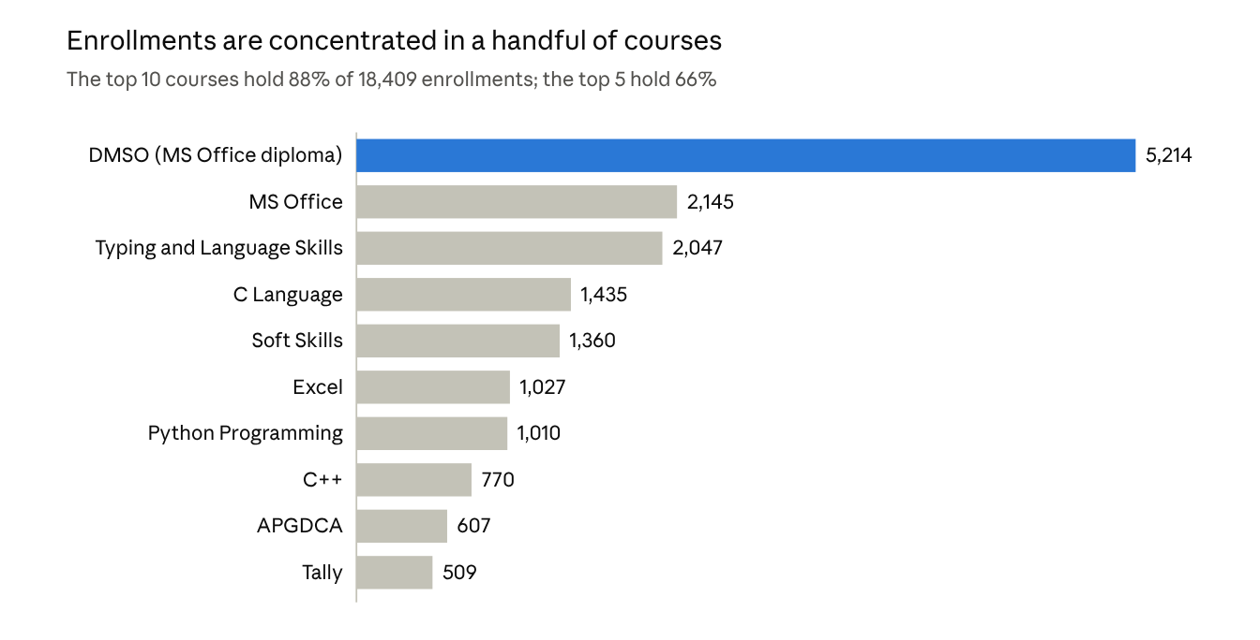
course_enrollments export, Overall sheet · top 10 of 63 courses
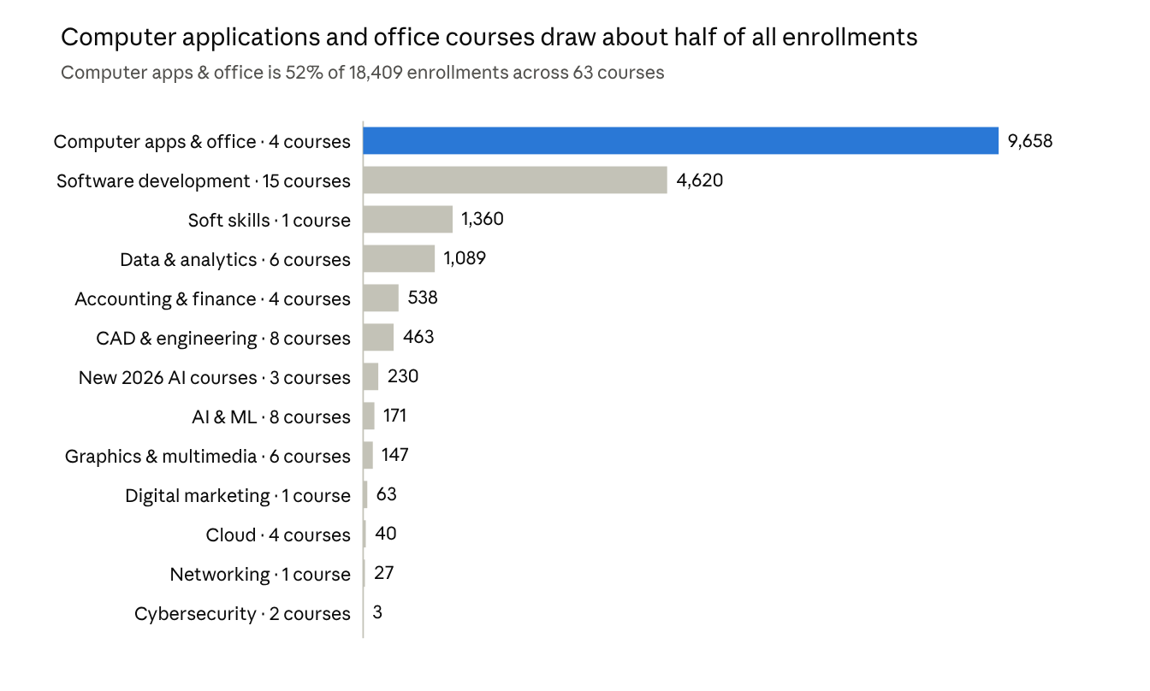
course_enrollments export, Overall sheet · categories grouped by course-code prefix (inferred)
Category names are inferred from the course-code prefixes (for example DP-CAO, DP-SD, DP-DA); the three courses with 2026 course codes are grouped separately. Beginner-level courses carry 17,267 of the enrollments (94%) across 39 courses. Certification courses hold 18,057 enrollments, while the 10 Premium courses hold only 233 and the single Core course (Soft Skills Development) holds 119.

5. Course-wise enrollment counts
All 49 courses with enrollments, highest first.
# | Course | Code | Type | Level | Hours | Enrolled
1 | DMSO - Diploma in Microsoft Office and Office Automation | DP-CAO-801 | Certification | Beginner | 40 | 5,214
2 | MS Office | DP-CAO-802 | Certification | Beginner | 46 | 2,145
3 | Typing and Language Skills | DP-CAO-803 | Certification | Beginner | 40 | 2,047
4 | C Language | DP-SD-705 | Certification | Beginner | 48 | 1,435
5 | Soft Skills | DP-SSC-1201 | Certification | Beginner | 40 | 1,360
6 | Excel | DP-DA-405 | Certification | Beginner | 48 | 1,027
7 | Python Programming | DP-SD-712 | Certification | Beginner | 80 | 1,010
8 | C++ | DP-SD-706 | Certification | Beginner | 44 | 770
9 | APGDCA - Advanced Post Graduate Diploma in Computer Applications | DP-SD-704 | Certification | Intermediate | 40 | 607
10 | Tally | DP-ANF-503 | Certification | Beginner | 42 | 509
11 | Core Java | DP-SD-710 | Certification | Beginner | 46 | 450
12 | AutoCAD | DP-CAD-1000 | Certification | Beginner | 46 | 372
13 | DCA - Diploma in Computer Applications | DP-CAO-800 | Certification | Beginner | 42 | 252
14 | Artificial Intelligence | DP-AIML-106 | Premium | Advanced | 148 | 170
15 | GEN AI | CRS-2026-0908-122346 | Certification | Beginner | 40 | 127
16 | Soft Skills Development | DP-SD-703 | Core | Advanced | 1 | 119
17 | Web Development and Full Stack | DP-SD-714 | Certification | Beginner | 46 | 105
18 | Photoshop and Graphic Design | DP-GDM-903 | Certification | Beginner | 42 | 67
19 | Data Structures and Algorithms | DP-SD-708 | Certification | Intermediate | 48 | 63
20 | Digital Marketing | DP-DM-600 | Premium | Advanced | 148 | 63
21 | DTP - Desktop Publishing | DP-GDM-902 | Certification | Beginner | 42 | 61
22 | Full Stack Python & AI Development | CRS-2026-0904-152356 | Certification | Advanced | 864 | 52
23 | AI TOOLS | CRS-2026-0908-143143 | Certification | Advanced | 15 | 51
24 | SQL and Database | DP-DA-404 | Certification | Beginner | 48 | 43
25 | CATIA | DP-CAD-1002 | Certification | Beginner | 42 | 37
26 | AWS and Cloud Computing | DP-CC-201 | Certification | Beginner | 48 | 34
27 | Networking and CCNA | DP-NIT-1100 | Certification | Beginner | 48 | 27
28 | DCFA - Diploma in Computerised Financial Accounting | DP-ANF-501 | Certification | Beginner | 46 | 26
29 | Revit and SketchUp | DP-CAD-1005 | Certification | Beginner | 42 | 23
30 | Programming and Coding | DP-SD-711 | Certification | Beginner | 42 | 20
31 | DSE - Diploma in Software Engineering | DP-SD-709 | Certification | Beginner | 42 | 15
32 | .NET | DP-SD-707 | Certification | Beginner | 46 | 14
33 | Software Testing | DP-SD-713 | Certification | Beginner | 46 | 12
34 | 3ds Max and Animation | DP-GDM-904 | Certification | Beginner | 46 | 10
35 | Power BI | DP-DA-403 | Certification | Beginner | 40 | 10
36 | Primavera and MS Project | DP-CAD-1004 | Certification | Beginner | 44 | 10
37 | Data Science, Analytics and AI | DP-DA-402 | Certification | Beginner | 46 | 9
38 | ANSYS | DP-CAD-1001 | Certification | Intermediate | 40 | 8
39 | STAAD Pro | DP-CAD-1007 | Certification | Beginner | 38 | 7
40 | Video and Audio Editing | DP-GDM-905 | Certification | Beginner | 40 | 5
41 | SolidWorks | DP-CAD-1006 | Certification | Beginner | 42 | 4
42 | Cybersecurity and Ethical Hacking | DP-CS-301 | Certification | Intermediate | 44 | 3
43 | DPT - Diploma in Page-Making and Typography | DP-GDM-901 | Certification | Beginner | 36 | 3
44 | DevOps | DP-CC-203 | Certification | Intermediate | 48 | 3
45 | Microsoft Azure | DP-CC-202 | Certification | Beginner | 48 | 3
46 | SAP | DP-ANF-502 | Certification | Intermediate | 40 | 3
47 | QGIS and GIS | DP-CAD-1003 | Certification | Beginner | 42 | 2
48 | AI Workshop | DP-AIML-107 | Certification | Beginner | 2 | 1
49 | Digital Media and ADMM - Advanced Diploma in Multimedia | DP-GDM-900 | Certification | Beginner | 40 | 1

6. Courses with no enrollments yet
These 14 active courses have zero enrollments. Most are the newer Premium AI, Cloud and Data programs.
- Advanced Java (DP-SD-701)
- Agentic AI & Autonomous Workflows Program (DP-AIML-105)
- AI Engineering & Deployment Program (DP-AIML-104)
- AI Essentials for Everyone (DP-AIML-100)
- AI Foundations with Python (DP-AIML-101)
- Cloud Computing (DP-CC-200)
- Cyber Security & Ethical Hacking Program (DP-CS-300)
- Data Analytics - Power BI (DP-DA-401)
- Data Analytics - Python (DP-DA-400)
- Forward Deployed Engineer (FDE) (DP-SD-702)
- Generative AI & LLM Engineering Program (DP-AIML-103)
- Machine Learning & Deep Learning (DP-AIML-102)
- Python Full Stack (DP-SD-700)
- Tally Prime with GST and Accounting (DP-ANF-500)

